Wasatch Front Travel Demand Model
Version 8.3.2

Telecommuting
Assumptions
Summary

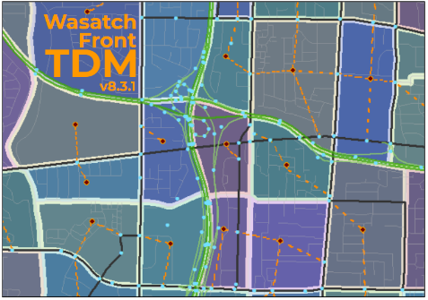
For Model Release Date: September, 2021
Table of Contents
Updated Networks – Aug 17, 2020 1
Input Data 2
Socioeconomic Data 2
Plan Amendment 2
SR 201 Connection 3
Update for Cube 6.4.5 4
Segment Summary 5
Assignment Output Folder 6
Access to Opportunity 6
Miscellaneous Changes 7

Reason to Add Telecommute Capability to the Travel Model
Observed data over the last decade (2010-2019) has shown a shift towards increased telecommuting, or remote working. In 2020, the Coronavirus 19 pandemic brought an acute focus onto telecommuting as more than half of the workforce on the Wasatch Front was forced to work from home.
The Wasatch Front Travel Demand Model (WF TDM) does not

Observed Data Trends

Socioeconomic Data
A very minor change was made to the socioeconomic data in Utah County. A few households had been located in the Utah Lake TAZ. These were removed and relocated into nearby TAZ. This change would have very little affect to model results.

